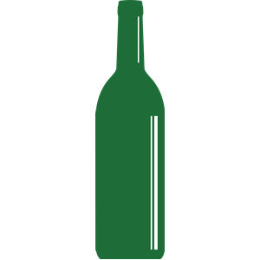

WINE TASTING NOTES

WINE | APPEARANCE | NOSE | TASTE | RATING
APPEARANCE: watery, clear, pale yellow, straw, golden, bright berry, purple, dark purple, crimson red, garnet, brownish, cloudy
NOSE: floral, herbal, perfumed, citrusy, vanilla, buttery, spicy, smoky, leathery, funky, grassy, meaty, musty
TASTE: plummy, fruity, flowery, clean, peppery, earthy, acidic, tannic, luscious, long, balanced, full, flowery, sexy, velvety, powerful

